9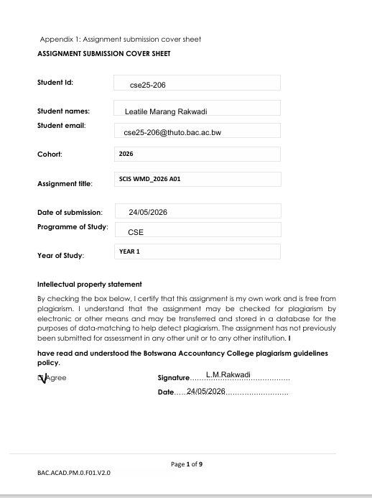

WEBSITE SPECIFICATIONS

Website Objective and Business Goals
The main goal of this website is to help people learn about weightlifting and fitness. It will provide training programs, workout plans, exercise tutorials, fitness tips, nutrition advice, and schedules. This will help users improve their strength, stay healthy, and reach their fitness goals. At the same time, the website will help the owner grow a business in the fitness industry.
The website aims to:
- Attract many users, from beginners to advanced weightlifters.
- Make money through paid programs, diet plans, subscriptions, or advertisements.
- Build trust by providing accurate and helpful fitness information.
- Keep users interested in interactive features like schedules and progress tracking.
- Promote products or services, like fitness equipment or personal training.
- Regularly update content, so users keep returning.

b) TARGET AUDIENCE
The website is for:
Age group: 16–45 years old
iGender: All genders
Occupation: Students, gym-goers, office workers, and fitness enthusiasts
Technical Skills: Basic to intermediate computer skills; can use websites and mobile apps
Interests: Fitness, weightlifting, healthy lifestyle, nutrition, workout tracking

c) TYPE OF WEBSITE /CONTENT
This is an informational and instructional website.
Content includes:
- Home
- About
- Training programs
- Workouts
- Tutorials
- Nutrition
- Register
- Contact

2. INFORMATION DESIGN & TAXONOMY
Information Design
The website is organized into clear sections: Home, About, Training Programs, Workouts, Tutorials, , Nutrition, Register, Contact.
Each page has headings, images, videos, and short explanations.
Users can easily find information without confusion.
Taxonomy (How content is grouped)
TRAINING PROGRAMS – Beginner, Intermediate, Advanced
WORKOUTS – Full Body, Upper Body, Lower Body
TUTORIALS – Chest, Back, Arms, Legs
NUTRITION-Diet Plans, Healthy Foods, Supplements
REGISTER- create account, log in , dashboard
CONTACT-questions and feedback
SITE MAP
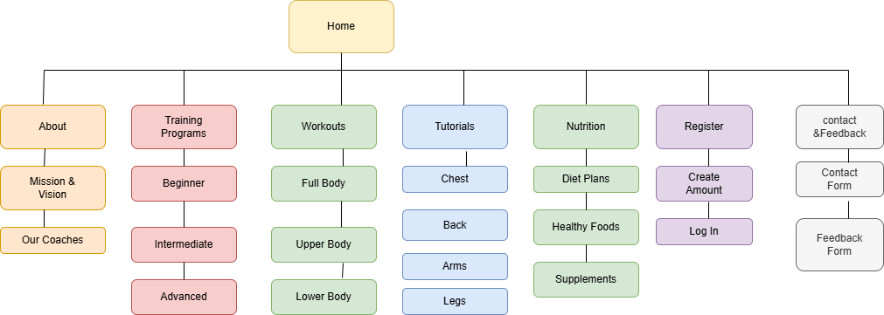

Home → links to all main section
About> Subcategories: mission, vision, coaches .
Training Programs → subcategories: Beginner, Intermediate, Advanced
Workout Plans → subcategories: Full Body, Upper Body, Lower Body
Exercise Tutorials → subcategories: Chest, Back, Arms, legs
Nutrition → subcategories: Diet Plans, Healthy Foods, Supplements.
Registration : create account, log in , dashboard.
Contact Page → questions and feedback.

4. TECHNICAL BRIEF
Technologies and Tools:
- HTML5 – page structure
- CSS3 – styling and colors
- Bootstrap – responsive layout for mobile devices
- JavaScript -for interactive features
- Notepad++ – for coding
- GitHub – for version control
- GitHub Pages – for publishing the website

QUALITY ASSURANCE
BROWSER COMPATILITY
My website has been tested in Google chrome, Microsoft edge and Firefox.
Everything is working; all the buttons are clickable; all photos are showing. Throughout all the browsers, the videos are not working.
Google Chrome

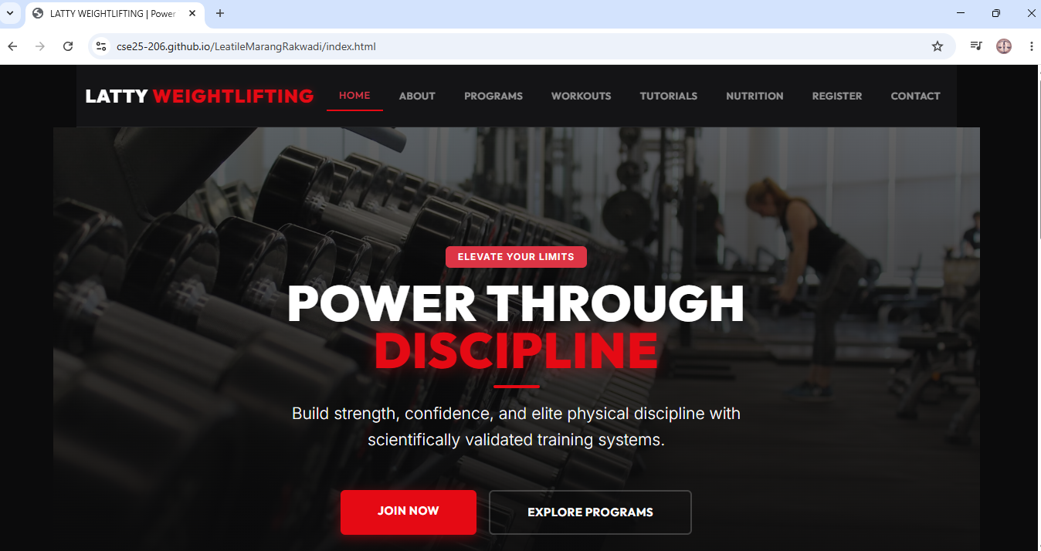

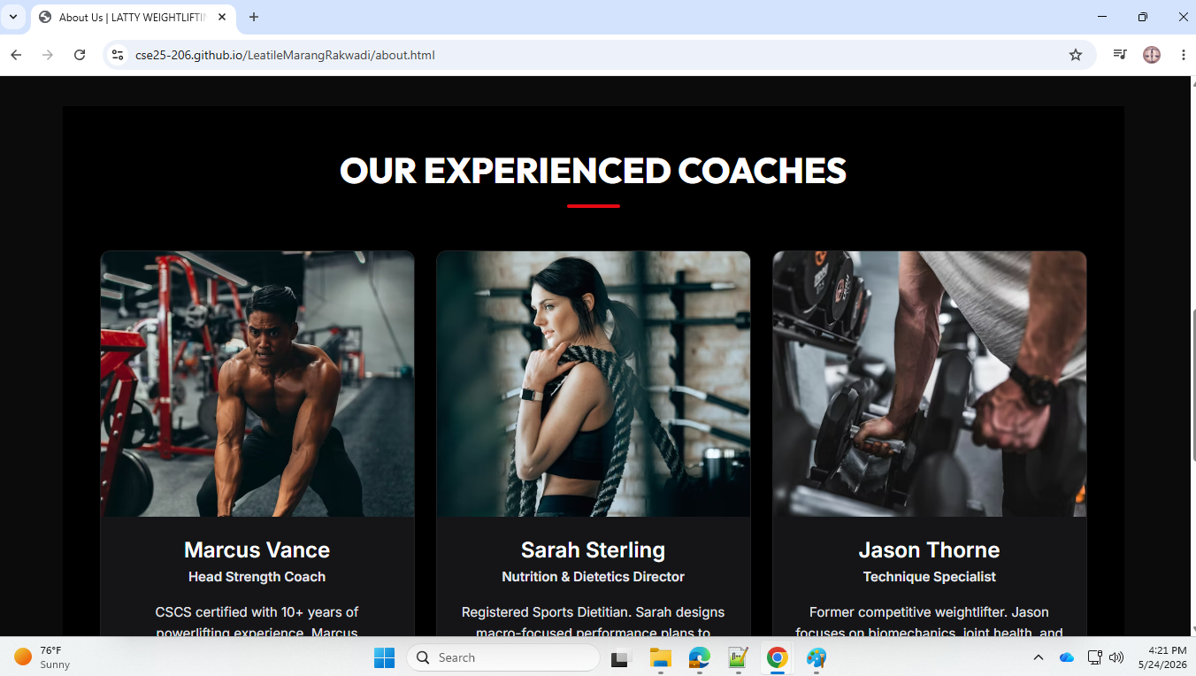MICROSOFT EDGE
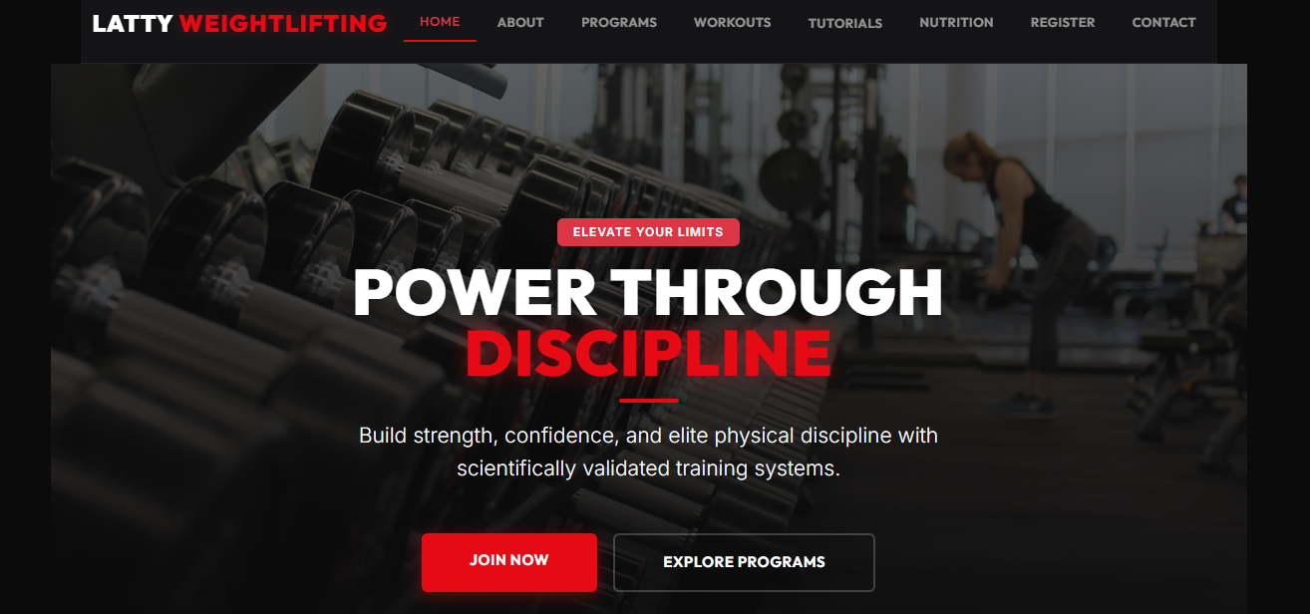FIREFOX
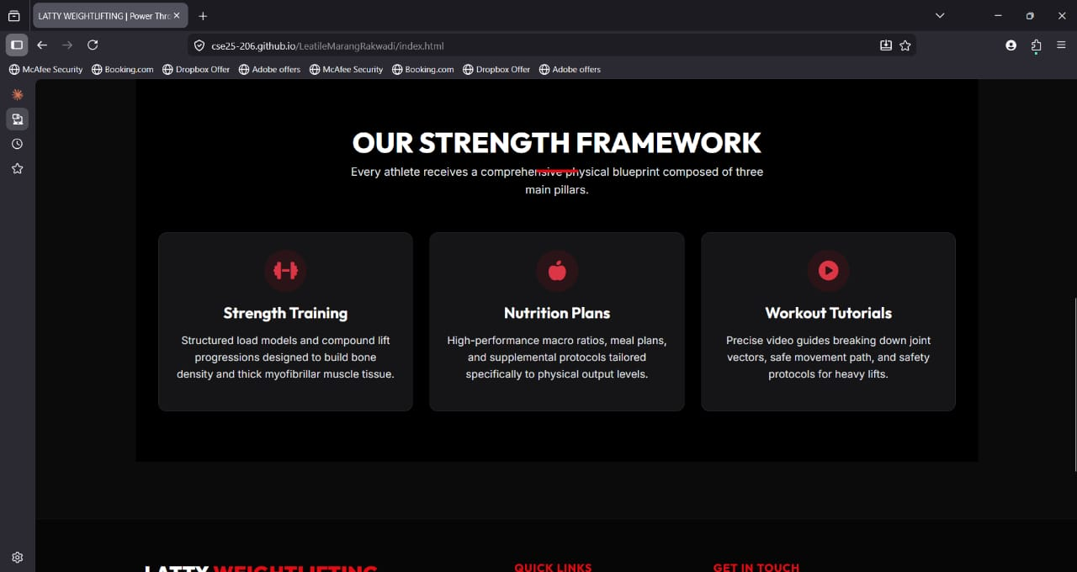

DEVICE COMPATIBILITY
The website can open on both desktop and mobile devices.in the mobile devices only one video can play, all photos show, while in desktop videos don't play at all, all photos show.
LAPTOP
MOBILE PHONE

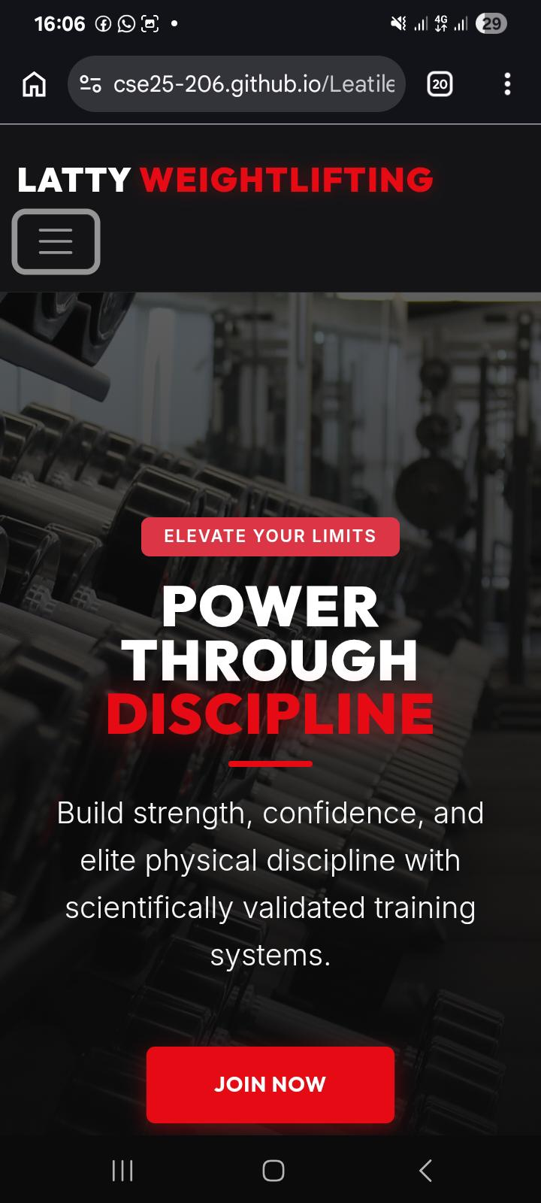

PUBLISHING AND PROMOTION
The website was published using
- GitHub Repository
- GitHub Pages

FUTURE DEVELOPMENTS
- The videos on the website are not playing; I will insert working videos on my website.
- I will add social media links to the footer.
- I will add user dashboard with their progress.

